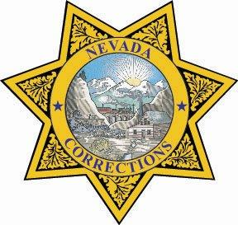

Joe Lombardo

*Governor*

James E. Dzurenda

*Director*

Ronald Oliver

*Warden*

Northern Administration

5500 Snyder Ave.

Carson City, NV 897010

(775) 977-5500

Southern Administration

3955 W. Russell Rd.

Las Vegas, NV 89118

(725) 216-6000

**MEMORANDUM**

Date: March 17, 2025

To: SDCC Staff

Subject: New Visiting schedule

Starting on April 7, 2025, until July 1, 2025, Visitation will be operating on a temporary

modified bi-weekly schedule as stated below:

|  |  |  |
| --- | --- | --- |
| APRIL | MAY | JUNE |
| 7, 11, 12, 13 | 5, 9, 10, 11 | 2, 6, 7, 8 |
| 21, 25, 26, 27 | 19, 23, 24,25 | 16, 20, 21, 22 |
|  |  | 30 |

If there is any additional information that is needed, please contact me.

Ronald Oliver, Warden

Southern Desert Correctional Center